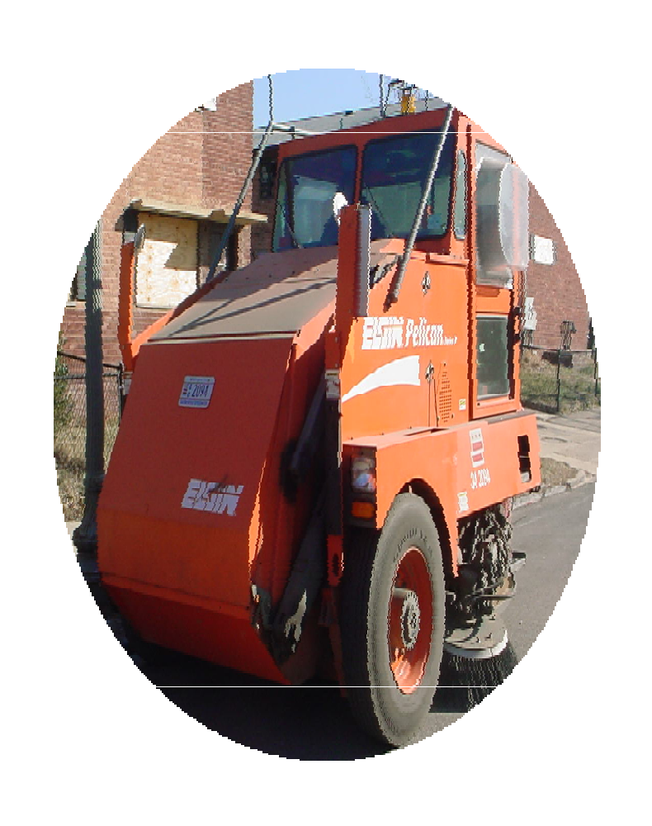
Procedures to apply for the March 1 through October 31 residential street sweeping program and installation of the NO PARKING SIGNS FOR STREET CLEANING are as follows:

- A petition must be completed for each street location. A minimum of three contiguous blocks is required to be considered for the program.

- Petitions filed must have the signatures of individuals representing at least 80% of the residences on the block.

  - If an apartment building is located within the block, then each apartment unit is to be counted as a separate residence.

- The Department of Public Works, Solid Waste Management Administration (DPW/ SWMA) will inspect the blocks, taking into consideration the amount of litter and the total number of residences to determine the feasibility of mechanically sweeping the area. DPW/SWMA will verify all signatures. DPW/SWMA also will inspect the blocks for proposed designated locations of poles and signs.

- In cases where poles need to be installed Miss Utility will need to be notified. (This may cause some delays in the process.)

- For traffic safety reasons, petitions will not be considered in the middle of a one-way street, rush hour restriction roadways and commercial corridors roadways.

- DPW/SWMA will notify the local ANC commission and the Block Captain, if any, of a particular block requesting street sweeping and the approval of a petition. The local ANC office will be given the opportunity to advise the government on this issue as required by District of Columbia Law.

- Upon a decision on the petition, DPW/SWMA will notify the local ANC, the Block Captain, and the citizen generating the petition of the determination. DPW/SWMA will reserve the right to deny any petition. If approved, the notification will indicate the date on which the NO PARKING FOR STREET CLEANING signs will be installed.

- The District Department of Transportation (DDOT) will install the NO PARKING FOR STREET CLEANING signs and DPW/SWMA will notify the affected residents of the date when sweeping will begin.

- The Department of Public Works, Solid Waste Management Administration will monitor locations to ensure that scheduled services are being provided and regulations are followed. Each location that does not conform to rules and regulations will be released from the Street Sweeping Program.

- At any time when services are not rendered, call the Mayor’s Citywide Call Center at 311.

- Mechanical street sweeping services in residential neighborhoods are temporarily suspended every year between November 1 and February 28 (or February 29, Leap Year), when temperatures traditionally drop below freezing. Parking restrictions related to residential mechanical street sweeping are lifted during the suspension.

For
“Alternate Side”

Mechanical Street Sweeping

To: Anthony Duckett
Chief, Street and Alley Cleaning Division
Department of Public Works, Solid Waste Management Administration
1831 Fenwick Street, NE
Washington, DC 20002

We the undersigned abutting residents of the hundred block of (Street Name), (quadrant) petition the Department of Public Works to install the NO PARKING FOR STREET CLEANING signs to provide for routine street cleaning on a weekly posted schedule.

We agree to the following efforts to support DPW in maintaining clean streets.

- Move our car(s) accordingly on scheduled service days. However, we are aware that if our cars are not moved during the posted street cleaning times, we will receive a “parking” citation.
- Maintain public space free of debris from our property line and extending eighteen inches (18in) from the curb line into abutting roadway-( Section 702.1)

The attached signatures represent 80% or more of the affected residents.

The ANC and Block Captain who will serve as points of contact with the Department of Public Works are:

ANC Name Signature-(Required) Address & Telephone Number ANC Area

Block Captain Name Address & Telephone Number ANC Area

********Official Office Use Only******
□ Approval / □ Denial Signature |  |  |  |  |  |  |  |  | Sign Installation
Signature: |  |  |  |  |  | Date |  |  | Signature: |  |  |  | Date
Mon | Tues |  | Wed | Thurs | Fri. |  |  | AM |  | PM | Service Effective Date

Signature | Date | Address | Phone
Mail or present petitions to:
Department of Public Works, Solid Waste Management Administration
1831 Fenwick Street, NE
Washington, DC 20002
Telephone Number (202) 727-7908
Anthony.duckett@dc.gov

Signature | Date | Address | Phone
Mail or present petitions to:
Anthony Duckett
Department of Public Works, Solid Waste Management Administration
1831 Fenwick Street, NE
Washington, DC 20002
Telephone Number (202) 727-7908
Anthony.duckett@dc.gov

